**XOR Encryption**

James Porter

Department of Computer Science, Southern New Hampshire University

CS 405 Secure Coding

Professor Wasim Alim

October 2, 2022

**Exception Console Window**

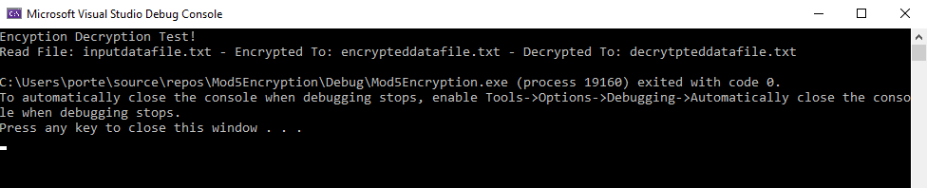

**Summery**

The first step for this assignment was for me to learn about XOR encryption. This was not an overly difficult task in and of itself, but it was a step in the process. Then I went through the code looking for TODO sections. I was able to get through most of the TODO sections with no issues and was ready to turn in the assignment days ago, but I could not get the correct date line to work so I took a step back. I knew there was a way to do it where I got the current time in seconds and calculated out what the date was, but I knew that would not be the best way to implement the date requirement in this assignment. After taking the break, I looked closer at the strftime() documentation to see if that was the option that would work best for me. After messing with this function for a while, I was delighted to see that it worked.